### Random Forest Algorithm

Random Forest is a popular machine learning algorithm that belongs to the supervised learning technique. It can be used for both Classification and Regression problems in ML. It is based on the concept of **ensemble learning,** which is a process *of*combining multiple classifiers to solve a complex problem and to improve the performance of the model.As the name suggests, **"Random Forest is a classifier that contains a number of decision trees on various subsets of the given dataset and takes the average to improve the predictive accuracy of that dataset."** Instead of relying on one decision tree, the random forest takes the prediction from each tree and based on the majority votes of predictions, and it predicts the final output.**The greater number of trees in the forest leads to higher accuracy and prevents the problem of overfitting.**

* Data Pre-processing step
* Fitting the Random Forest algorithm to the Training set
* Predicting the test result
* Test accuracy of the result (Creation of Confusion matrix)
* Visualizing the test set result.

### How the Random Forest Algorithm Works

The following are the basic steps involved in performing the random forest algorithm:

1. Pick N random records from the dataset.
2. Build a decision tree based on these N records.
3. Choose the number of trees you want in your algorithm and repeat steps 1 and 2.
4. In case of a regression problem, for a new record, each tree in the forest predicts a value for Y (output). The final value can be calculated by taking the average of all the values predicted by all the trees in forest. Or, in case of a classification problem, each tree in the forest predicts the category to which the new record belongs. Finally, the new record is assigned to the category that wins the majority vote.

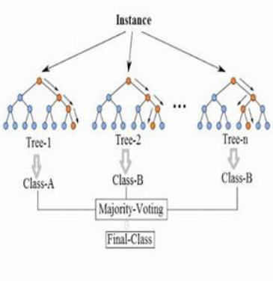

### Advantages of using Random Forest

As with any algorithm, there are advantages and disadvantages to using it. In the next two sections we'll take a look at the pros and cons of using random forest for classification and regression.

1. The random forest algorithm is not biased, since, there are multiple trees and each tree is trained on a subset of data. Basically, the random forest algorithm relies on the power of "the crowd"; therefore the overall biasedness of the algorithm is reduced.
2. This algorithm is very stable. Even if a new data point is introduced in the dataset the overall algorithm is not affected much since new data may impact one tree, but it is very hard for it to impact all the trees.
3. The random forest algorithm works well when you have both categorical and numerical features.
4. The random forest algorithm also works well when data has missing values or it has not been scaled well (although we have performed feature scaling in this article just for the purpose of demonstration).

### Disadvantages of using Random Forest

1. A major disadvantage of random forests lies in their complexity. They required much more computational resources, owing to the large number of decision trees joined together.
2. Due to their complexity, they require much more time to train than other comparable algorithms.

Throughout the rest of this article we will see how Python's [Scikit-Learn library](http://scikit-learn.org/stable/index.html) can be used to implement the random forest algorithm to solve regression, as well as classification, problems.